Portal Page Plan
Colors
Primary 1 = #dae0f2
Primary 2 = #84a07c
Accent 1 = #004348
Accent 2 = #004348
Accent 3 = #02111b
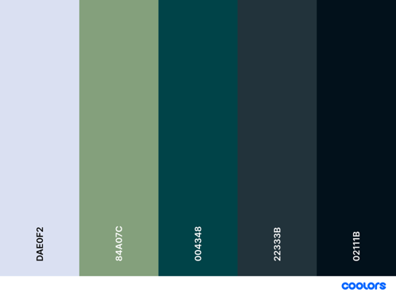
Fonts – from google fonts
Playwrite New Zealand Basic = headings
Inter = body
Wireframe
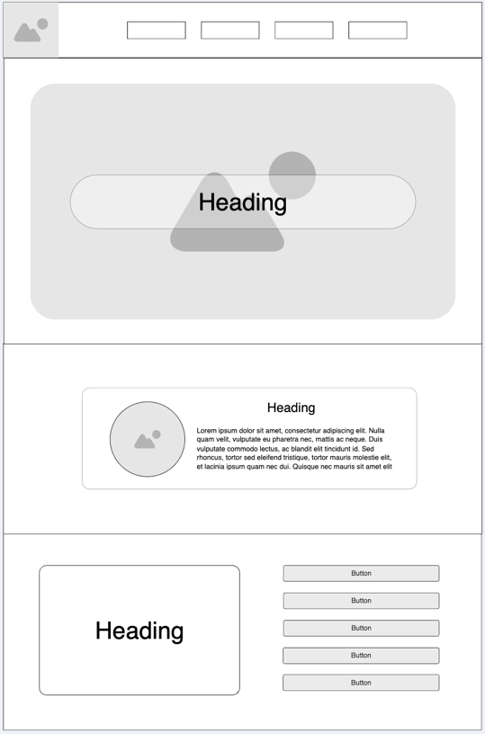
Logo


